Chapter -1

1.1 Introduction

As the world population and energy demand increases, the consumption of conventional fuels also increases. The limited sources of conventional fuels have directed researcher’s attention towards renewable energies viz., solar, wind, tidal and biomass in recent years. Of the available renewable energies, solar energy offers an excellent alternative to conventional fuels as it is most abundant and a permanent energy source. Solar energy directly provides the necessary energy requirements for human need. According to Kalogirou [2004], 30 minutes of total solar radiation falling on earth is equal to the world’s energy demand for one year. Compared to conventional fuels, solar energy is non-polluting, has no moving parts to breakdown and does not require much maintenance [Abu-Hamdeh 2003].
Solar technologies are classified into passive and active techniques. Passive solar techniques include designing spaces to have natural circulation, locating buildings in aligning with the sun or by selecting high thermal conductive materials. On the other hand, active solar technique includes using solar panels, pumps or fans convert the solar energy into useful outputs. The solar energy is extensively applied in:
- Industrial process heating
- Electricity generation (solar thermal power plant, photovoltaic systems)
- Greenhouse heating
- Domestic hot water heating: Evacuated-tube solar collectors, integral collector- storage systems, flat-plate collector
- Space heating and cooling

Solar collector absorbs the incoming solar radiant energy and converts into thermal energy at the absorbing surface and transmits it to a fluid flowing through the collector. There are two types of solar collector namely flat plate and concentrating collector. A flat plate collector has the area of interception same as that of absorption for the solar radiations, while a concentrating collector usually has a concave reflecting surface to intercept and focus the sun’s beam radiation on to a smaller receiving area, thereby increasing the radiation flux substantially.
A flat plate collector consists of a flat surface with high absorption of solar radiations, called the absorbing surface, typically a metal plate, painted black. The solar energy is transferred from the absorber plate to a carrier fluid circulating across the collector. Thermal insulation is usually placed on the rear side to prevent heat losses. The front side has transparent covers, generally glass that allows transmission of incoming solar radiation but is opaque to the infrared radiations from the absorber plate. Flat plate collectors are permanently fixed in position and do not require tracking of the sun. Flat plate solar collectors are classified based on the type of heat transfer fluid used as liquid heating and air heating collectors [Ramani et al. 2010].
Solar air heaters (SAHs) are cheap and extensively used as a solar energy collection device that utilizes solar radiation for a variety of purposes [El-khawajah et al. 2011]. SAHs consist of panels, insulated hot air duct and air blowers in active systems, whereas SAH without a blower is passive. The panel consists of an absorber plate and one or two transparent covers which allow the solar radiation to penetrate the collector. The absorber plate of SAH absorbs the solar radiation, and transfers 3 the heat to the working fluid (air). The working fluid (air) flows through the SAH over the plate, thereby collecting the heat absorbed by the plate via convection. SAH can be classified into porous and non-porous depending on the types of the absorber plate. According to the number of passes, SAH can be classified into single-pass and dual-pass [Pratim et al. 2013].
SAHs has a wide range of application such as delivering heated air at low to moderate temperatures for drying agricultural products (i.e., fruits, seeds, and vegetables), and in some industrial applications [Akpinar et al. 2004]. Besides, the SAHs are utilized for heating buildings with auxiliary heaters to save energy in winter season [Qenawy and Mohamad 2007].
There are many advantages of SAH systems viz., simple to design and maintain, less leakage and corrosion than systems employing liquid [Mohamad 1997], eco-friendly with zero greenhouse emissions, and no fuel expenditure beyond set-up cost. On the other hand, SAHs have two inherent disadvantages i.e., low thermal capacity of air and low absorber plate to air heat transfer coefficient [Esen 2008]. Consequently, several studies to determine the thermal performance of SAHs have been conducted, theoretically and /or experimentally, and different modifications are suggested and applied to improve the heat transfer coefficient between the absorber plate and air. These modifications include using an absorber with fins attached [Yeh and Lin 1996, Labed et al. 2012], roughened absorber [Sahu and Bhagoria 2005, Chaube et al. 2006], corrugated absorber [Karim and Hawlader 2006, El-Sawi et al. 2010] and porous bed absorber [Abu-Quidis and Al-Nimr 1996, Ramadan et al. 2007, Sopian et al. 2009].

1.2 Problem Statement
Although SAH has vast potential, it has not received much attention like the solar liquid heaters [Parker et al. 1993, Karim and Hawlader 2004]. SAH occupies an important place among solar heating systems because of minimal use of materials. Furthermore, the direct use of air as the working fluid reduces the number of system components. Handling large amounts of the working fluid (air) with a low thermal capacity and low convective heat transfer coefficient are the major problems of SAHs till date.
Various researchers developed novel designs to improve the thermal performance of SAHs over the past few decades. However, the thermal performance of SAHs is low owing to lower thermal conductivity of air and lower convective heat transfer coefficient between absorber plate and air, resulting in higher absorber plate temperature and greater heat losses to the ambience. The heat transfer coefficient between absorber and flowing air strongly influences the thermal performance of SAH dictated by the type of construction and operating parameters. Esen [2008], Akpinar and Koҫyiğit [2010] and El-khawajah et al. [2011] in different studies reported increases in heat transfer rate, pressure drop and power consumption while increasing the mass flow rate and modifying absorber plate geometries viz., corrugated, obstacles and porous medium.
The performance measurement of SAH at outdoor conditions is hard [Simon 1976, Garg 1985], due to (1) steady solar radiation level is difficult to attain owing to the intermittent and frequent movement of cloud cover and (2) comparison of varied configuration SAH performance is not viable, as solar intensity varies from time to time and day to day. Whereas an indoor setup which is easier and quicker, offer an excellent alternative to determine the thermal performance of SAHs at 5 uniform solar intensity [Chandra and Sodha 1991]. To maintain steady climatic conditions, experiments were carried out with an artificial solar simulator at a radiation intensity of 600 W/m2 as recommended by Indrajit et al. [1985] and Sophian et al. [2009].
In this study, an attempt is made to improve the heat transfer coefficient between absorber plate and air, by formulating different modifications viz., absorber plate geometry and flow configuration (number of passes), and operating parameters viz., radiation intensity and mass flow rate in SAHs at indoor ambience. Further, in this study, efforts were made to increase heat transfer rate and reduce the pressure drop and power consumption SAH.

1.3 Objective
1. To construct an indoor solar simulator and tested with various geometries of absorber plate and flow configurations
2. To enhance the heat transfer rate of proposed SAHs with minimum pressure drop.
3. To study the performance of proposed SAHs theoretically and correlated experimentally.
4.To assess the performance of proposed SAHs under varied mass flow rate and solar intensities.
5.To perform exergy analysis for the proposed SAH.
6.To determine the optimal SAH configuration and operating parameter in economic perception.

1.4 Scope
In this study, experiments were conducted using an indoor setup simulating real time conditions. However, the same can be verified in actual open-air conditions. In this research, v- corrugated wire mesh was used in the second pass to enhance the heat transfer rate of SAH. The same can be introduced in both (first and second) passes and left for future work. Further, diameter of wire used in the wire mesh and the cross-section opening can be varied learning the thermal performance of SAH. The flow channel depth and width are maintained as constant in this study. Yet variation in channel depth and width to vary the flow area can also be tried. On the other hand, numerical simulation of these works can also be performed.
One of the challenges facing the world currently is how to minimize energy consumption using fossil fuels due to the negative socio-environmental impacts and price volatility.
One of few approaches is to increase renewable energy sources such as solar as an Alternative clean source to protect the environment, adhere to global and national policies geared towards clean energy development as well as increase energy access, to urban and rural areas. Solar energy can be electricity or heat using two different conversions technologies: photovoltaic system of the and solar collector. Solar energy is mostly used in the form of electricity or heat for commercial or a very residential application. Therefore, integration of a combined photovoltaic and thermal system should be a considered to address the low energy efficiency observed when the two solar energies conversion of the technologies are employed separately, to obtain higher overall energy efficiency ensuring better a utilization of solar energy and the solar panel.
1.5 Methodology Flow Chart
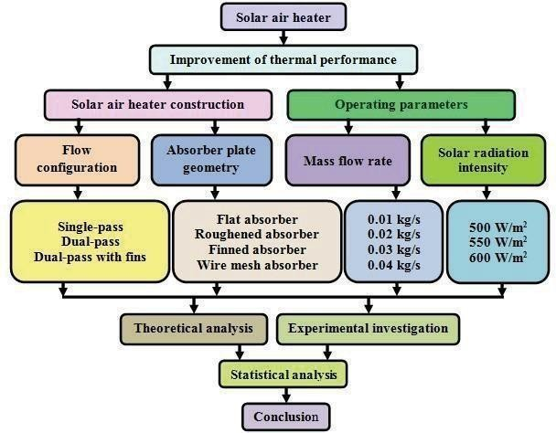

Figure: 1.4.1 Methodology Flow Chart

1.6 Methodology
An extensive literature survey of articles related to SAH highlights the significance of the the problem stated. SAH with different absorber plate geometries were fabricated and tested at a various flow configurations, mass flow rate and radiation intensities. Theoretical models are developed for each condition and the results correlate with the experimental findings.

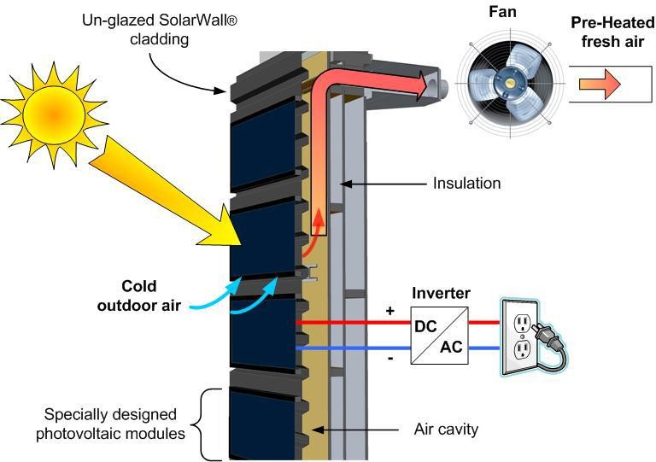
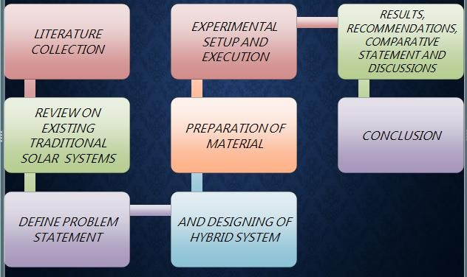
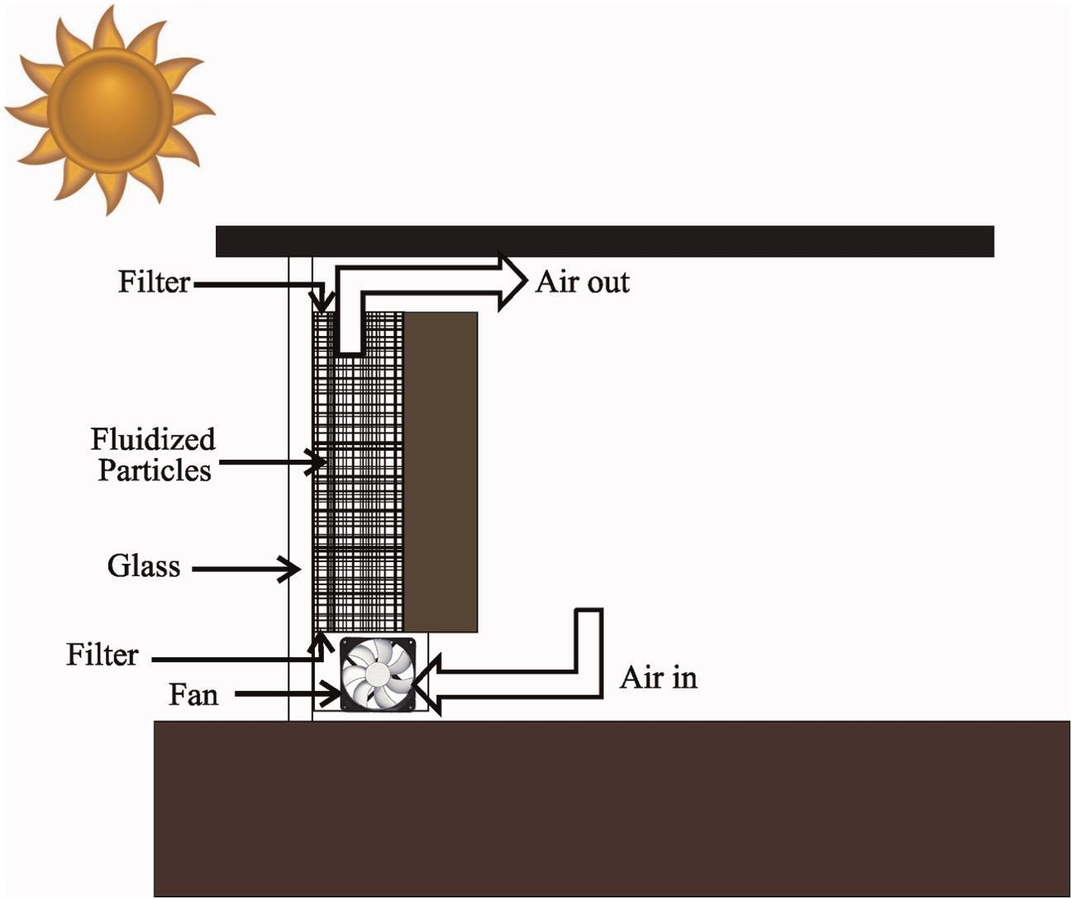
1.7 Organization of Dissertation

Objectives:

- The prime objectives of this present research are to perform indoor experiments on proposed SAHs.
- The output parameters and capabilities of the collector will be in the be explored and the documented, with the intent of determining usefulness.
- The specific objectives can be summarized in the following points are the to construct an indoor unit of solar simulator and tested with various geometries of absorber plate and flow configurations. To enhance the heat.
- Transfer rate of proposed SAHs with minimum pressure drop. To study the performance of proposed the SAHs theoretically a correlated and experimentally.
- To assess the performance of proposed SAHs under varied mass flow rate and solar intensities unit. To perform exergy analysis for the proposed SAH.
- To design and fabricate lightweight aluminum structure.
- To design system with hybrid output i.e., solar, and thermal.
- To study the graph of solar energy vs time.

Chapter - 2

2.1 Literature Review

Conventional SAH mainly consist of a panel, insulated hot air duct and air blower in active systems. The panel consists of an absorber plate and transparent cover which affects the SAH efficiency. A major heat loss from conventional SAH is found to be top losses, whereas heat losses from the bottom and sides are negligible owing to adequate insulation. To minimize the heat losses (top losses) and to improve the efficiency, dual glassing was recommended [Prasad et al. 2009, Alta et al. 2010]. Yeh and Lin [1996] stated that in conventional, the area available for heat transfer is lesser than the projected area of the absorber, as it becomes unnecessarily hot leading to higher heat losses. The same was confirmed by Lin et al. [2006], Akpinar and Koҫyiğit [2010] and Benli [2013], who stated that, the convective heat transfer rate in flow channel is augmented by increasing the heat transfer surface area and turbulence inside the channel. Increase in absorber plate projected area enhances the heat transfer rate and, consequently, pressure drop across the SAH and the power consumption for air flow through the SAH increases [Esen 2010]. Ozgen et al. [2009], Ramani et al. [2010] and Aldabbagh et al. [2010] suggested dual-pass mode to restrict heat losses, enhancement in heat transfer rate and efficiency without increasing heater size or cost. From the above discussion, it can be concluded that the flow configuration, absorber plate and its geometry play a vital role in deciding the thermal performance of a SAH. Hence, in the following sections, major contributions by different researchers on flat plate SAHs including all the variants are discussed.

2.1.1 Flat absorber SAHs

In 1995, Yeh and Lin investigated the effect of the collector aspect ratio on the energy efficiency of flat plate SAHs theoretically and experimentally with varied flow rates and reported that energy efficiency increases with the mass flow rate and collector aspect ratio. While Naphon and Kongtragool in 2003 applied mathematical models for predicting the heat transfer characteristics of flat plate SAH with various flow configurations and found that single flow dual- pass flat plate SAH exhibit higher thermal performance. In the meantime, Forson et al. [2003] conducted theoretical and experimental investigation with single-pass dual duct flat plate SAH and reported that the mass flow rate dictates the overall efficiency of SAH. The thermal performance of flat plate SAH employing electrical field was attempted by Kiatsiriroat et al. [2007] who reported better heat transfer rate at the high radiation intensity and lower mass flow rate. Employing external recycle improves the thermal efficiency in flat plate SAHs was reported by Yeh and Ho [2009]. optimum aspect ratio (length to width ratio of the absorber plate) and optimum duct depth (the distance between absorber and bottom plates) for maximum exergy delivery in flat plate solar air heater and concluded that if the inlet temperature of air is low, maximum exergy output is achieved at lower mass flow rate. Few years later, Jafarkazemi and Ahmadifard [2013] evaluated the energy and exergy performance of flat plate solar collector and reported reduction in energy efficiency and increase in exergy efficiency with augment in inlet temperature

2.1.2 Roughened absorber SAHs
The first citation on roughened absorber SAH was by Prasad and Saini [1998], who investigated the effect of relative roughness height and pitch on heat transfer and 9 friction factors in transverse ribs. Karwa et al. [2001] carried out an experimental investigation to determine the thermal performance of SAHs with chamfered repeated rib-roughness on the airflow side of the absorber plates and achieved substantial enhancement in thermal efficiency over SAH with smooth absorber plate. Bhagoria et al. [2002] used wedge shaped ribs to enhance the heat transfer coefficient and reported a maximum heat transfer enhancement at a wedge angle of 10o. In addition, they obtained an increase in friction factor with wedge angle. Sahu and Bhagoria [2005] investigated the effect of different pitches having 90o broken wire rib roughness in SAH and reported enhancement of thermal performance by 1.25-1.4 times. Jaurker et al. [2006] investigated the effect of rib-grooved and ribbed artificial roughness on heat transfer and friction characteristics of SAH, who concluded that the thermo-hydraulic performance of rib-grooved artificial roughness was higher than ribbed one. An experimental study was also carried out by Varun et al. [2009], who investigated the efficiency of SAH with transverse and inclined ribs as artificial roughness elements on the absorber and reported combination of roughness geometry provides better performance over the transverse ribs. Gupta and Kaushik [2009] in their article published correlated the performance of artificial roughness absorber SAH with smooth absorber SAH. They concluded that exergy is more for SAH with roughness at lower mass flow rate. Remarkable efforts are made by Karwa and Chauhan [2010], Karmare and Tikekare [2010] and Prasad [2013] to study the effect of rib roughness over the absorber plate on thermal performance of SAHs. They indicated that the artificial roughness breaks the viscous sub-layer and increases the heat transfer rate with the penalty of undesirable increase in pressure drop due to increased friction. In 2013, Benli concluded that the heat transfer coefficient and the pressure drop changes with configuration of absorber surface while experimentally 10 analyzing the energy and exergy of varied absorber surface viz., corrugated, trapeze, reverse corrugated, reverse trapeze, and a base plate.

2.1.3 Finned absorber SAHs
A better thermal efficiency in a dual flow SAH having fins, was reported by Yeh et al. in 2002, where the cross-sectional area and mass flow rate of upper and lower flow channels is equal. In 2004, Moummi et al. conducted an energy analysis and flow characteristics of finned SAH both experimentally and theoretically and reported better thermal performance while employing fins. Two years later, Ucar and Inalli [2006] conducted energy and exergy analyses with staggered absorber sheets and attached fins concluded largest irreversibility is occurring at the conventional SAH, where thermal efficiency is smallest. Meanwhile, Youcef-Ali and Desmons in2006 and Peng et al. in 2010 unconnectedly recommended providing fins for enhancing the thermal performance. Alta et al. [2010] investigated three different types of SAHs (two having fins and the other without fins, one of the heaters with fins had single glass cover and the others had dual glass covers) and concluded that, dual glass covers, and fins are more effective and the rise in air temperature is higher based on energy and exergy output. One year later, Ho et al. [2011] obtained higher thermal performance in an upward type of dual-pass SAH with fins along with external recycling. In a subsequent publication Ho et al. [2012] reported SAH with fins and baffles was economically viable than dual pass SAH with fins based on the ratio of efficiency and power consumption increment.

2.1.4 Absorber with obstacles SAHs

In 2008, Esen compared the results of dual flow SAH with and without obstacles. The influences of parameters viz., obstacles in absorber plate, mass flow rate of air and absorber plate level in duct on the energy and exergy efficiencies of 11 SAH were examined. Later, Ozgen et al. [2009] attempted dual flow SAH with aluminum cans, reported higher thermal performance owing to enhancement of heat transfer area. The energy and exergy analysis of flat plate SAH with several obstacles positioned at different angles was experimentally studied by Akpinar and Koҫyiğit [2010]. They also correlated those results with SAH without obstacles and found that the energy and exergy efficiency of SAHs significantly depends on the solar radiation, surface geometry of SAHs and the extension of the air flow line. In addition, they reported that exergy loss of SAH decreased depending on the increase of the energy efficiency.

2.1.5 Corrugated absorber SAHs
Karim and Hawlader [2006] compared the thermal performance of flat plate, v- corrugated and finned air collectors. They concluded that v-groove collector is the most efficient collector, and the flat plate collector is the least efficient one. They also found that the v- groove collector has 7-12% higher efficiency than flat plate collectors. Notable efforts are made by compared the results with a flat plate and v-grooved absorber plate. These studies show that the thermal performance of cross corrugated SAH is superior to v-grooved and flat plate SAHs. El- Sawi et al. [2010] investigated both theoretically and experimentally flat plate, v-grooved and chevron pattern absorber SAHs and concluded that, chevron pattern absorber SAH performance was better than flat plate and v-grooved absorber SAH. El-Sebii et al. [2011] investigated the thermal performance of dual flow finned and v-corrugated plate SAH both theoretically and experimentally and concluded that dual flow v-corrugated plate SAH was 9-12% more efficient than dual flow finned plate SAH.

2.1.6 Porous bed absorber SAHs
Thakur et al. [2003], studied the effect of porosity on the heat transfer rate covering a wide range of geometrical parameters of wire screen matrix (wire diameter 0.795-1.4 mm, pitch 2.5-3.19 mm, number of layers 5-12) and reported a decrease in porosity which increases the volumetric heat transfer coefficient. Ozturk and Demirel [2004] evaluated the energy and exergy efficiencies of SAH having it flow channel packed with Raschig rings. They observed that the energy and exergy efficiencies of the packed-bed SAH increased as the outlet temperature of heat transfer fluid increased. Naphon [2005] numerically analyzed the heat transfer characteristics and performance of dual-pass flat plate SAH with and without porous media and stated that variation in efficiency from 38% to 59% for the bed without porous media, whereas it ranges from 42% to 70% with porous media for mass flow rates between 0.03 and 0.07 kg/s respectively. El- Sebaii et al. [2007] used limestone and gravel as packed bed materials and reported a thermal efficiency of 65% at a mass flow rate of 0.05 kg/s, while the pressure drop was 400 N/m2. Further, they recommended operating the system with a packed bed at a mass flow rate lower than 0.05 kg/s to attain lower pressure drop and high thermal efficiency. A thermal performance investigation of dual glass, dual-pass SAH with a packed bed (limestone and gravel), based on mass flow rate and porosity was carried out by Ramadan et al. [2007]. Ramadan et al. reported better thermal performance while employing gravel as packed bed material. Prasad et al. [2009] presented an investigation on a packed bed SAH using wire mesh as a packing material for air flow rate ranging from 0.0159 to 0.0347 kg/s. They reported that the efficiency of packed bed SAH with a porosity of 0.599 increases from 53.3% to 68.5% compared with conventional SAH. Moreover, they opined that the efficiency increases with decreasing the porosity of the 13 beds. The performance of single and dual-pass SAH with fins and steel wire mesh as absorber was studied by Omojaro and Aldabbagh [2010] who found that the efficiency of dual-pass was higher than single- pass by 7-9%. El-khawajah et al. [2011] attempted a novel design of employing dual-pass SAH with wire mesh and fins instead of absorber plate and reported better thermal performance than conventional SAH. The counter and parallel flow packed bed SAHs was investigated by Dhiman et al. [2012]. The results showed that the thermal efficiency of counter flow packed bed SAH is 11- 17% more than parallel flow packed bed SAH. Economic analysis on dual pass SAH with and without wire mesh was carried out by Ho et al. [2013] and reported that the dual pass SAH with wire mesh is economically feasible based on the ratio of efficiency and power consumption increment. El-khawajah et al. [2015] employed wire mesh and fins instead of the absorber plate in single-pass SAH and reported maximum thermal efficiency and outlet temperature for conditions exhibiting more fins along with wire mesh.
Chapter - 4

3.1 Design
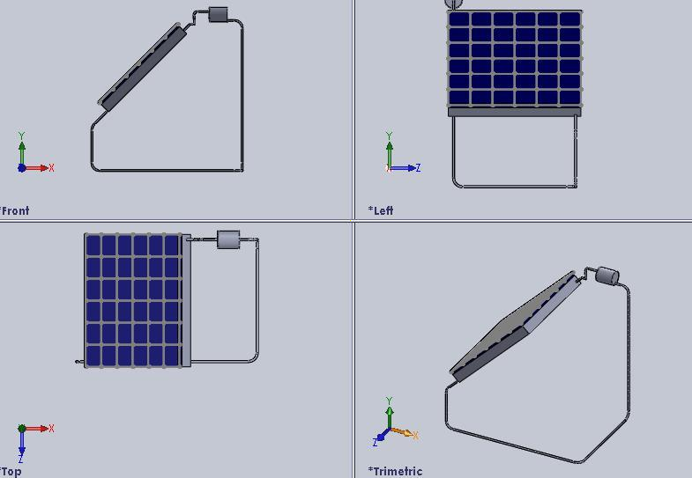

Figure 3.1.1 CAD Diagram

3.2 Experimental Setup
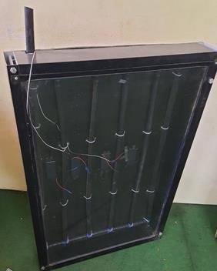
The conventional SAH consists of panels, insulated hot air duct and air blower inactive systems. A glass cover is fixed above the absorber plate and the system is thermally insulated from back and on the sides. The following section describes the proposed SAHs with solar simulator, and measuring devices, experimental procedure, and uncertainty analysis. The photographic view and schematic line diagram of the experimental setup is shown in Figures respectively. The basic components of experimental setup are solar air heater with solar simulator and measuring devices.

Figure 3.2.1 Photographic view of Experimetal Setup Model
Solar Air Heater

The solar air heater is constructed in such a manner that it can be dismantled, and its elements (glass cover, absorber plate and back plate of duct) can be reassembled to vary the collector flow configuration. In this study, seven types of absorber plate surfaces viz., flat, roughened, top surface roughened and finned at bottom, finned, finned at both top and bottom, wire mesh, wire mesh on top and finned at the bottom are designed and tested in a single solar collector assembly which evades making of several collectors. The various geometries of single- pass SAH, dual-pass SAH and dual-pass SAH with fins are schematically illustrated in Figures. The collector frame consists of two steel boxes, each 2 m long, 0.46 m wide and 0.025 m depth as recommended by Beckman et al. [1977]. The frame of the collector is made of 1.5 mm thick mild steel internally painted with black and externally insulated by 2.5 cm thick polystyrene. Two similar window glasses of 4 mm thickness each were used as glazing. The distance between the upper (cover-1) and lower glass (cover-2) is maintained as 2.5 cm [Lof 1980]. In all flow configurations, the depth of each flow channel is 2.5 cm. In single-pass SAH, air is flowing between lower glass cover (cover-2) and absorber plate, where the bottom of the absorber plate is insulated with 2.5 cm thick
The single-pass SAH consist of four different geometries of absorber surface viz., flat, roughened, finned and wire mesh. The absorber plate dimension and plate thickness are 2 m × 0.46 m and 0.001 m, respectively. The absorbers were made of mild steel 40 with black coating. Roughened absorber surface is fabricated with a mild steel wire of diameter (e) 1.5 mm and pitch (p) 15 mm. Prasad [2013] optimized the relative roughness pitch (p/e) and relative roughness height (e/Dh) for SAH as 10 and 0.0316 respectively and these parametric values are employed in this study. Finned absorber surface is fabricated with 17 longitudinal fins made of mild surface is fabricated with a mild steel wire of diameter (e) 1.5 mm
and pitch (p) 15 mm. Prasad [2013] optimized the relative roughness pitch (p/e) and relative of a polystyrene. The single-pass SAH consist of four different geometries of absorber surface viz., flat, roughened, finned and wire mesh (Figures 4.3-4.6). The absorber plate dimension and plate thickness are 2 m × 0.46 m and 0.001 m, respectively (Figures 4.7-4.10). The absorbers were made of mild steel 40 with black coating. Roughened absorber surface (Figure 4.8) is fabricated with a mild steel wire of diameter (e) 1.5 mm and pitch (p) 15 mm. Prasad [2013] optimized the relative roughness pitch (p/e) and relative roughness height (e/Dh) for SAH as 10 and 0.0316 respectively and these parametric values are employed in this study. Finned absorber surface (Figure 4.9) is fabricated with 17 longitudinal fins made of mild steel whose dimensions are 1.98 m, 0.025 m and 0.001 m (length, height and thickness) respectively [Karim and Hawaldar 2006]. 0.3 mm diameter steel wire mesh consists of 2.5 mm × 2.5 mm in cross sectional opening (Figure 4.10). Single layer wire mesh painted with black is assembled in a transverse v-corrugated shape whose angle and height are 60o and 2.5 cm respectively. The length and depth of the wire mesh packing channel are 2m and 2.5 cm respectively is maintained, as it satisfies the limiting value of optical depth reported by Chiou et al. [1965]. The new design of v- corrugated wire mesh reduces the pressure drop as the porosity is very high (0.995). The porosity of the medium is defined as the fraction of the total volume of the medium occupied by void space. In dual-pass SAH, air is initially flow between two glass covers (cover-1, cover-2) and then passes between lower glass cover (cover-2) and absorber plate. The bottom of the absorber plate is insulated with 2.5 cm thick polystyrene. A rectangular single hole is provided on the right corner of the lower glass (cover 2) for the air to flow from first to second pass (see Figure 3.3, 3.6 and 3.9). The different geometries of absorber surface viz., roughened, finned and wire mesh is attempted in dual- pass SAH. In dual-pass SAH with fins, air is first circulated between back plate and absorber plate and then passed between lower glass cover (cover-2) and absorber plate, where the bottom of the back plate is insulated with 2.5 cm thick polystyrene. 41 A rectangular single hole is given on the right corner of the absorber plate for the air to flow from first to second pass (see Figure 3.4, 3.7 and 3.10). The dual-pass SAH with fins in three different top surface geometry variants of absorber surface viz., roughened, finned and wire mesh, along with 17 longitudinal fins made of mild steel whose dimensions are 1.98 m, 0.025 m and 0.001 m (length, height and thickness) respectively [Karim and Hawaladar 2006] fitted at the bottom of the absorber plate.

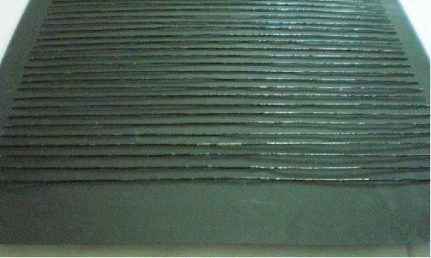
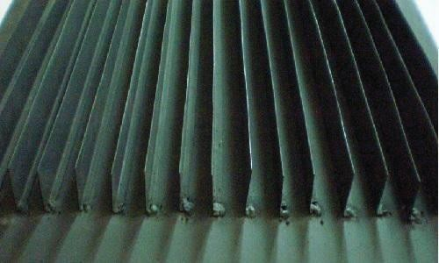
Figure 3.2.2 Photographic view of absorber plate with wire rib

Figure 3.2.3 Photographic view of absorber plate with longitudinal fins

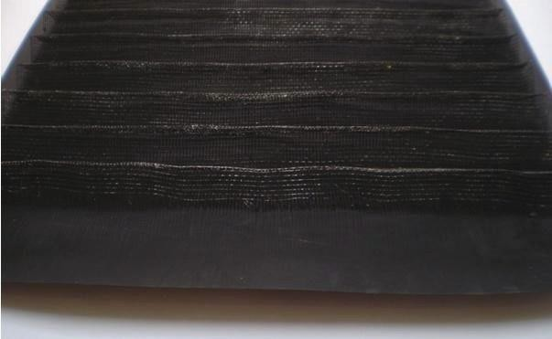
Figure 3.2.4 Photographic view of absorber plate with v-corrugated wire mesh

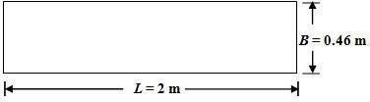

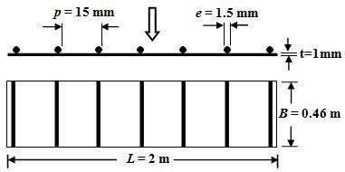

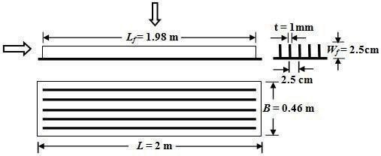
Figure 3.2.5 Finned absorber plate

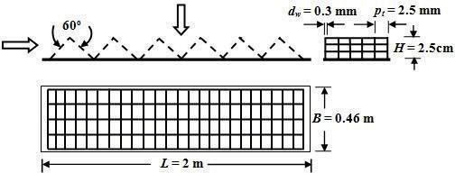

Figure 3.2.6 Absorber Plate with Wire Mesh

Chapter - 4

Simulation (Analytical/Numerical/FEM/CFD)
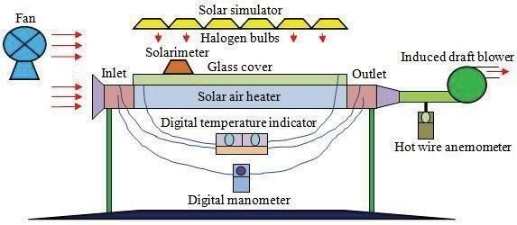
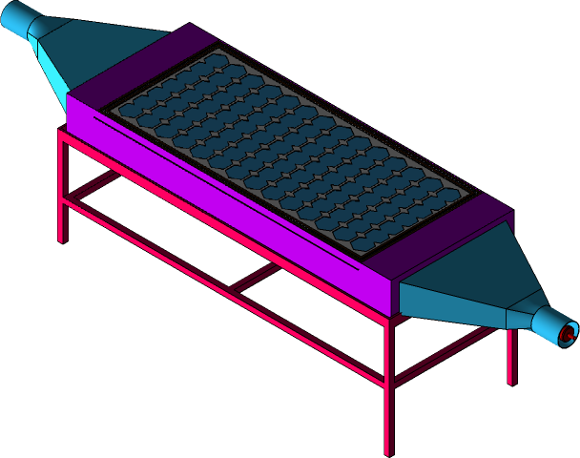
Figure 4.1.1 Schematic line diagram of the experimental setup with solar simulator

Figure 4.1.2 Prototype Cad diagram of solar air heater

4.1.1 Simulation
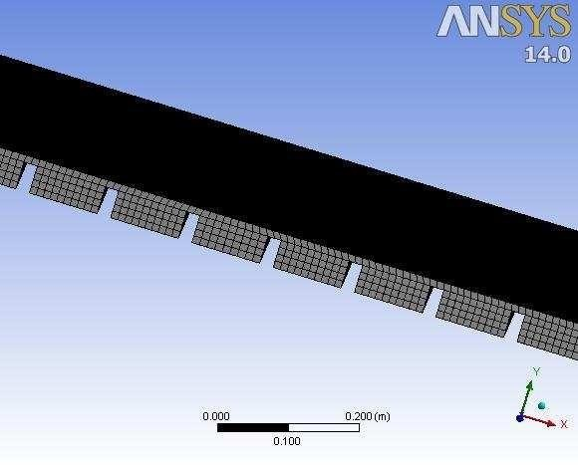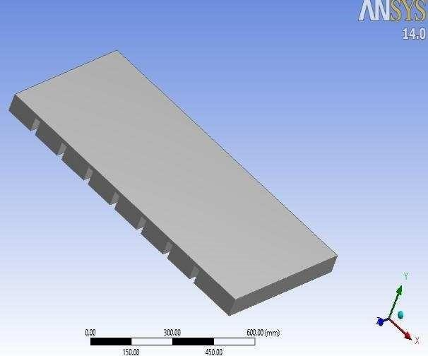
Fig 4.1.1.1 3D Mesh Fig 4.1.1.2 3D Modelling
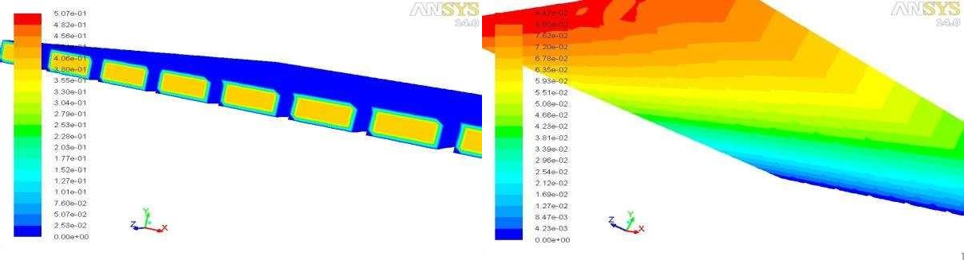
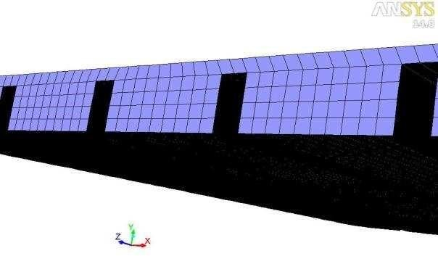
Fig 4.1.1.3 Contours of velocity magnitude(m/s) Fig 4.1.1.4contours of static pressure(pascal)
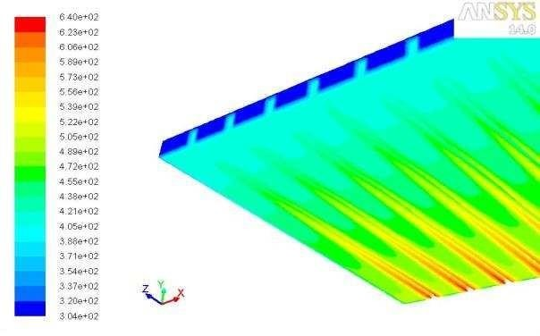

Fig 4.1.1.5 Meshing File in fluent software

Sr.  no. | Heat flux | Simulation results Outlet Temperature(k)
1. | 500 | 353
2. | 490 | 352
3. | 485 | 351
4. | 450 | 348
5. | 400 | 343
6. | 350 | 338
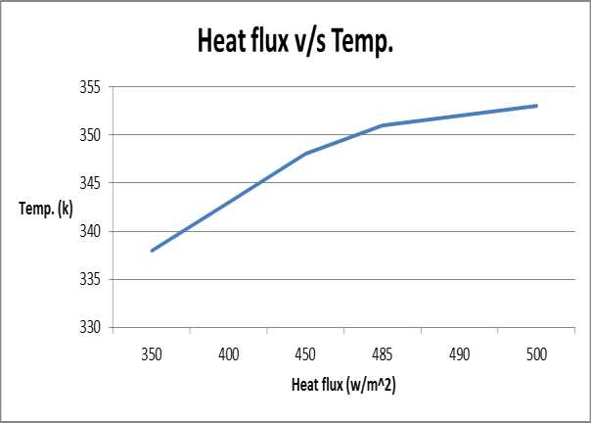

Table 4.1.1.1

Fig 4.1.1.6 Heat Flux/Temp Graph

Solar simulator
The top plane of the collector (glass cover) is uniformly heated by an incident radiation using solar simulator. The simulator uses 20 halogen lamps, each with a rated power of 300 W. The lamps are fixed on a frame having a similar area of the collector placed 1 m above the glass cover such that the maximum average radiation of 645 W/m2 can be reached at full load conditions. During experimentation, incident radiation was adjusted by the input power to the lamps, being controlled by two AC varies (4.5 kW each). The incident radiation was measured at the surface of the glass cover by using solarimeter (KIMO SL-100) shown in Table 4.1, calibrated by a standard pyranometer. The average value of the incident radiation on the collector top plane was determined as follows. The plain glass cover was divided into 20 sectors, and the measurement of the incident radiation was performed at each sector separately corresponding to input power to the lamps. The deviation of individual sectors measured values from that of the overall average values range from – 4.72% to 4.04%. This error range is within the allowable deviation of indoor tests for solar Figure Schematic line dia. Schematic line diagram of the experimental setup with solar simulator 39 collector performance standards [JIS A 4112-1994, BIS-BS 6757-1986], which indicates that deviations up to ±10% is acceptable.

Possible Outcomes
- In this study, experiments were conducted using an indoor setup simulating real time condition. However, the same can be verified in actual open-air conditions.
- In this research, v-corrugated wire mesh was used in the second pass to enhance the heat transfer rate of SAH. The same can be introduced in both (first and second) passes and left for future work
- Further, diameter of wire used in the wire mesh and the cross-section opening can be varied learning the thermal performance of SAH.

Chapter – 5
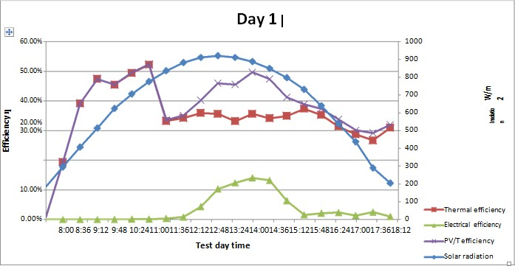
5.1 Result and Discussion
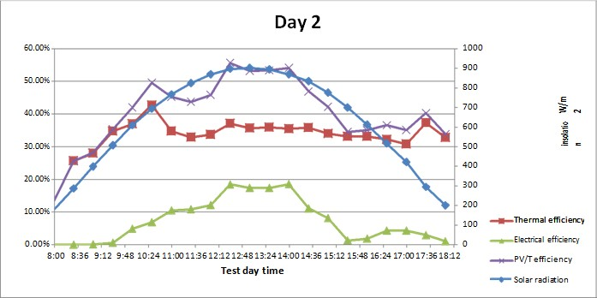
Graph 5.1.1 Day 1
Graph 5.1.2 Day 2

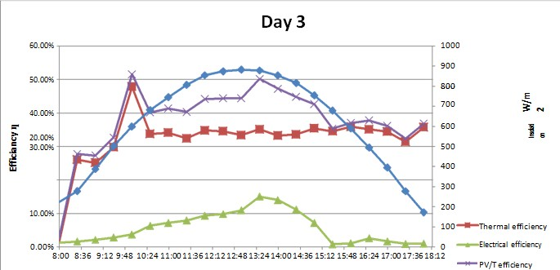
Graph 5.1.3 Day 3
1. At first day solar radiation was gained perfectly, as it was a clear day. Thermal efficiencies were recorded, and they were almost equal to theoretical calculated numbers. Electrical efficiencies were recorded, and they fluctuated at first but after half of the day it showed better results.
2. At the second day, Solar radiation was recorded to be normal and all other recorded (thermal efficiencies, electrical efficiencies, PV/T efficiencies) were very close to theoretical calculations.
3. At the third day, as the solar radiation was recorded unusually high, the other factors (thermal efficiencies, electrical efficiencies, PV/T efficiencies) were high too.

Chapter – 6

6.1 Concluding Remarks
To validate the present numerical model, results have been compared with available experimental results under similar flow conditions. CFD Investigation has been carried out in medium Reynolds number flow (Re ¼3800e18, 000). The conclusions are drawn from present analysis are Average Nusselt number increases with an increase of Reynolds number. The maximum value of average Nusselt number is found to be 43.577 for relative roughness pitch of 5 and for relative roughness height of 0.06 at a higher Reynolds number, 10,000. Average friction factor decreases with an increase of Reynolds number. The maximum value of average friction factor is found to be 1.698 for relative roughness pitch of 5 and relative roughness height of 0.06 at a lower Reynolds number, 5000.

6.2 Scope for the Future Work
In this study, experiments were conducted using an indoor setup simulating real time conditions. However, the same can be verified in actual open-air conditions. In this research, v- corrugated wire mesh was used in the second pass to enhance the heat transfer rate of SAH. The same can be introduced in both (first and second) passes and left for future work. Further, diameter of wire used in the wire mesh and the cross-section opening can be varied learning the thermal performance of SAH. The flow channel depth and width are maintained as constant in this study. Yet variation in channel depth and width to vary the flow area can also be tried. On the other hand, numerical simulation of these works can also be performed.

- This research establishes that there is potential for substantial monetary savings & reduction in GHG emissions if Solar PV Facades are used in high-rise buildings in Mumbai, India.
- The concept can also be applied for high-rise buildings in other parts of India as well. The payback period of less than 2 years is also very attractive.
- There is a need to include Solar PV Facades from the concept stage for high-rise buildings to ensure proper integration & minimum cost.
- Thin Film technology is a good choice for Solar PV Facades in India as demonstrated from the results with Cadet modules in this paper.
- Saving in land resource is also an advantage in using Solar PV for Facades.
- As electrical output of Solar PV Facade can be consumed in the high-rise building itself, it is a form of distributed generation with captive consumption avoiding trans-mission infrastructure & losses.

Chapter – 7
References
- Abu-Hamdeh NH. (2003) “Simulation study of solar air heater” Solar Energy 74: 309-317. Abu-Quidis MK, Al-Nimr MA. (1996) “Theoretical and experimental study on matrix solar air heater under transient condition” International Journal of Solar Energy 18: 137-146.
- Akpinar EK, Koҫyiğit F. (2010) “Energy and exergy analysis of a new flat plate solar air heater having different obstacles on absorber plates” Applied Energy 87: 3438-3450.
- Akpinar EK, Koҫyiğit F. (2010) “Experimental investigation of thermal performance of solar airheater having different obstacle on absorber plates” International Communication in Heat and Mass Transfer 37: 416-421.
- Akpinar EK, Sarsilmaz C, Yildiz C. (2004) “Mathematical modelling of a thin layer drying of apricots in a solar energized rotary dryer” International Journal of Energy Research 28: 739-752. 5.Aldabbagh LBY, Egelioglu F, Ilkan M. (2010) “Single and double pass solar air heaters with wire mesh as packing bed” Energy 35: 3783-3787.
- Alta D, Bilgili E, Ertekin C, Yaldiz O. (2010) “Experimental investigation of three differentsolar air heater energy and exergy analyses” Applied Energy 87: 2953-2973.
- Beckman WA, Klein SA, Duffie JA. (1977) “Solar heating design by the f-chart method” Wiley, New York.
- Benli H. (2013) “Experimentally derived efficiency and exergy analysis of a new solar air heaterhaving different surface shapes” Renewable Energy 50: 58-67.
- Bhagoria JL, Saini JS, Solanki SC. (2002) “Heat transfer coefficient and friction factor correlations for rectangular solar air heater duct having transverse wedge shaped rib roughness on the absorber plate” Renewable Energy 25: 341-369.
- BSI-BS 6757. (1986) “British standard methods of test for thermal performance of solarcollectors” British Standard Institution, London.
Chamoli S. (2013) “Exergy analysis of a flat plate solar collector” Journal of Energy in Southern Africa 24 (3): 8-13.
- Chandra R, Sodha MS. (1991) “Testing procedures for solar air heaters: A review” Energy Conversion Management 32(1): 11-33.
12.103 Chaube A, Sahoo PK, Solanki SC. (2006) “Analysis of heat transfer augmentation and flowcharacteristics due to rib roughness over absorber plate of a solar air heater” Renewable Energy 31: 317-331.
Chiou JP, El-Wakil MM, Duffie A. (1965) “A slit and expanded aluminium-foil matrix solar collector” Solar Energy 9: 73-80.
- Choudhury C, Chauhan PM, Garg HP. (1995) “Design curves for conventional solar air heaters”Renewable Energy 6(7): 739-749.
Dhiman P, Thakur NS, Chauhan SR. (2012) “Thermal and thermohydraulic performance of counter and parallel flow packed bed solar air heaters” Renewable Energy 46: 259-268.
- El-khawajah MF, Aldabbagh LBY, Egelioglu F. (2011) “The effect of using transverse fins on adouble pass flow solar air heater using wire mesh as an absorber” Solar Energy 85: 1479- 1487. El-khawajah MF, Egelioglu F, Ghazal M. (2015) “Finned single-pass solar air heaters with wiremesh as an absorber plate” International Journal of Green Energy 12(2): 108-116.
- El-Sawi AM, Wifi AS, Younan MY, Elsayed EA, Basily BB. (2010) “Application of folded sheet metal in flat bed solar air collectors” Applied Thermal Engineering 30: 864- 871.
- El-Sebaii AA, Aboul-Enein S, Ramadan MRI, El-Bialy E. (2007) “Year round performance ofdouble pass solar air heater with packed bed” Energy Conversion Management 48: 990-1003.
- El-Sebaii AA, Aboul-Enein S, Ramadan MRI, Shalaby SM, Moharram BM. (2011) “Thermal performance investigation of double pass-finned plate solar air heater” Applied Energy 88: 1727-1739.
- Esen H. (2008) “Experimental energy and exergy analysis of a double flow solar air of heaterhaving different obstacles on absorber plates” Building and Environment 43:1046- 1054.
- Farahat S, Sarhaddi F, Ajam H. (2009) “Exergetic optimization of flat plate solar collectors” Renewable Energy 34: 1169-1174.
- Forson FK, Nazha MAA, Rajakaruna H. (2003) “Experimental and simulation studies on a singlepass, double duct solar air heater” Energy Conservation and Management 44: 1209-
T. Matuska, “Performance and Economic Analysis of Hybrid PVT Collectors in Solar DHW System”, Energy Procedia, Volume 48, 2014, pp. 150-156.
21. H. A. Zondag, W. G. J. Van Helden, “Stagnation temperature in PVT collectors”. PV in Europe, Rome (Italy), 2002.
22. H. A. Zondag, “Flat-plate PV–thermal collectors and systems: a review”. Renewable an Sustainable Energy Reviews 12, 2008, pp. 891–959. doi: 10.1016/j.rser.2005.12.012. A. Parretta, M. Bombace, G. Graditi, R. Schioppo, “Optical degradation of long-term, field-aged c–
- Si photovoltaic modules”. Solar Energy Materials & Solar Cells 86, 2005, pp. 349–364. doi: 10.1016/j.solmat.2004.08.006
- V. Poulek., D. S. Strebkov, I. S. Persic, M. Libra. “Towards 50 years lifetime of PV panels laminated with silicone gel technology”. Solar Energy 86, 2012, pp. 3103–3108. http://dx.doi.org/10.1016/j.solener.2012.07.013
- N. Pokorny, “Type 223 - Detailed Mathematical Model of Glazed Solar Photovoltaic-Thermal Collector

